**FLUTTER QUALIFICATION DOCUMENTATION**

**LC036 – Faustina Odeta**

**YAMAHA MUSIC**

Yamaha Corporation is a Japanese multinational corporation that has a wide range of products and services. One of their focus is in manufacturing several musical instruments such as piano, guitar, drum, and many more. In this application – Yamaha Music, people can login into the application. The login page will show error message if the user input is invalid. If the input is valid, user will be redirected to the home page that contains an image carousel that shows the products of Yamaha Music. On the home page, user can change theme into dark theme and vice versa from by pressing the button on the top of the right page. User can also see the navigation bar by pressing the button on the top of the left page. The navigation bar shows the username of the logged user. On the shop page, it shows the items that Yamaha Music sells. The shop page contains of the product image, name, and price. User can press the button on the side of the product to see each detail. The detail page has two tabs, which is product details and comments. Product details tab contains of the product image, name, description, and price of the product. User can also leave a comment. If the comment is invalid, there will be a snackbar to show the error message. On the comment tab, user can see other username and their comments. Lastly, if the user presses the logout button, it will redirect to the login page.

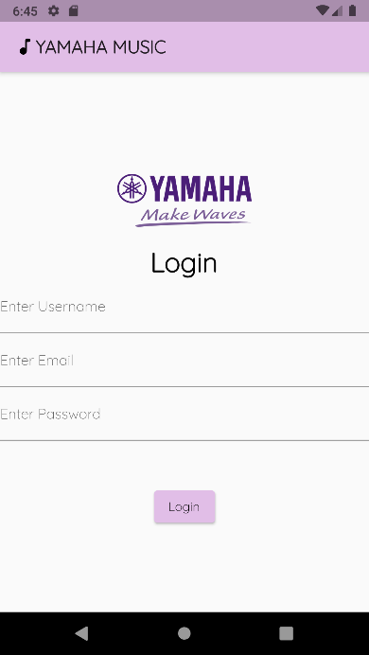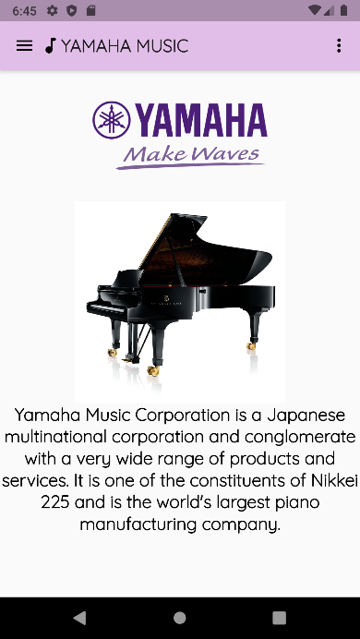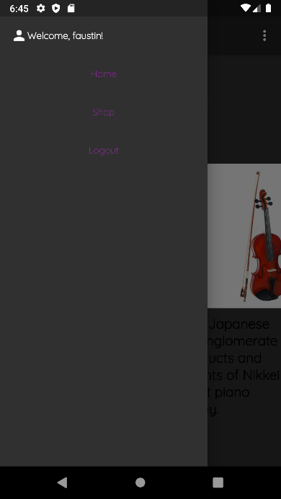**Login Login Error Home Page**

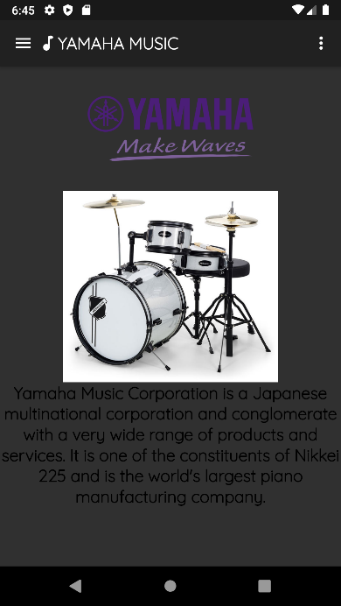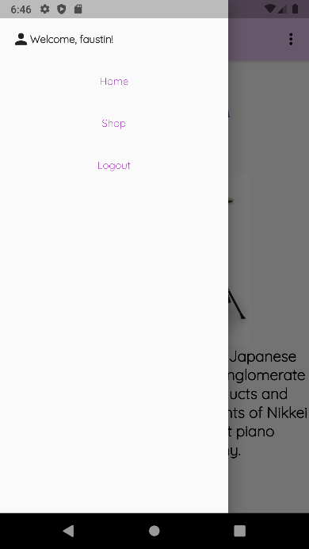

**Navigation Home Dark Theme Navigation Dark Theme**

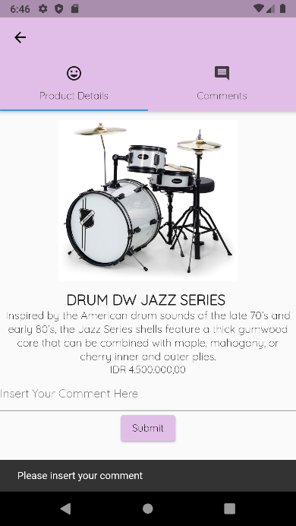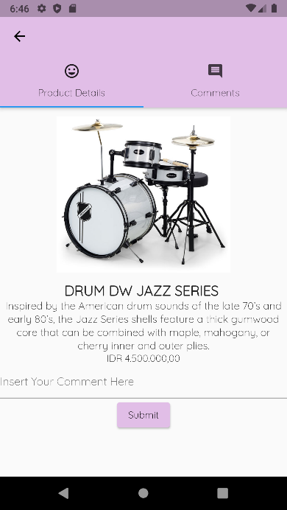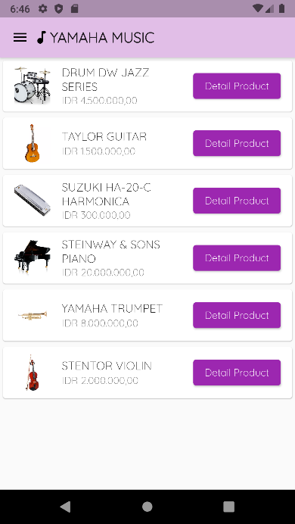**Products Detail Product Error Insert Comment**

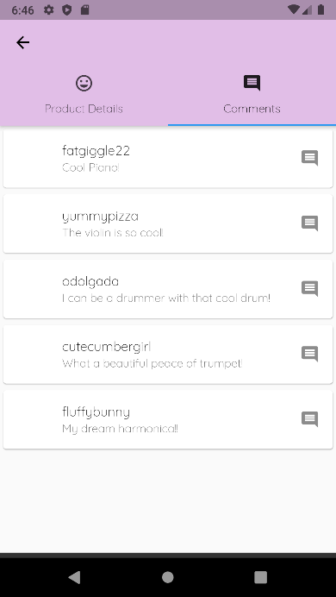

**Comments**

**REFERENCES:**

* **Logo**

[**https://www.yamaha.com/?header**](https://www.yamaha.com/?header)

* **Items**

**-. Piano**

[**https://upload.wikimedia.org/wikipedia/commons/8/8d/Steinway_%26_Sons_concert_grand_piano%2C_model_D-274%2C_manufactured_at_Steinway%27s_factory_in_Hamburg%2C_Germany.png**](https://upload.wikimedia.org/wikipedia/commons/8/8d/Steinway_%26_Sons_concert_grand_piano%2C_model_D-274%2C_manufactured_at_Steinway%27s_factory_in_Hamburg%2C_Germany.png)

**-. Violin**

[**https://www.static-src.com/wcsstore/Indraprastha/images/catalog/thumbnail//85/MTA-9114150/oem_acoustic-violin-fiddle-4-4-with-carry-case-bow-for-violinist-gift_full02.jpg**](https://www.static-src.com/wcsstore/Indraprastha/images/catalog/thumbnail//85/MTA-9114150/oem_acoustic-violin-fiddle-4-4-with-carry-case-bow-for-violinist-gift_full02.jpg)

**-. Guitar**

[**https://images.musicstore.de/images/0960/yamaha-c40-classical-guitar-_1_GIT0000636-000.jpg**](https://images.musicstore.de/images/0960/yamaha-c40-classical-guitar-_1_GIT0000636-000.jpg)

**-. Trumpet**

[**https://www.muzpro.eu/28120-large_default/vincent-bach-bb-trumpet-lt180-37g-stradivarius.jpg**](https://www.muzpro.eu/28120-large_default/vincent-bach-bb-trumpet-lt180-37g-stradivarius.jpg)

**-. Drum**

[**https://thumbs.static-thomann.de/thumb/orig/pics/bdb/467182/14593933_800.webp**](https://thumbs.static-thomann.de/thumb/orig/pics/bdb/467182/14593933_800.webp)

**-. Harmonica**

[**https://img.joomcdn.net/fd659e736cc7187f41bbbb3954d74dddc2d02f05_original.jpeg**](https://img.joomcdn.net/fd659e736cc7187f41bbbb3954d74dddc2d02f05_original.jpeg)

* **Font**

[**https://fonts.google.com/specimen/Quicksand**](https://fonts.google.com/specimen/Quicksand)

**LINK REPOSITORY:**

[**https://github.com/faustinaodetaa/LC036_Flutter_Qualification**](https://github.com/faustinaodetaa/LC036_Flutter_Qualification)